Noun Phrase

✅ Definition:
# Source: Chatgpt (GPT-4-turbo) at [7/28/2025]
A noun phrase is a group of words that functions as a noun in a sentence. It usually consists of a main noun (called the head noun) and may include modifiers, determiners, adjectives, and other words that give more information.

🧩 Key Features of a Noun Phrase:
# Source: Chatgpt (GPT-4-turbo) at [7/28/2025]
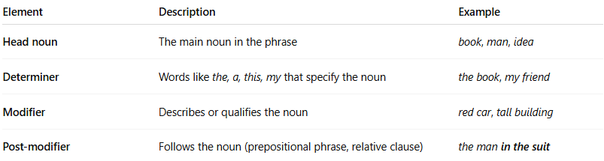
Element | Description | Example
Head noun | The main noun in the phrase | book, man, idea
Determiner | Words like the, a, this, my that specify the noun | the book, my friend
Modifier | Describes or qualifies the noun | red car, tall building
Post-modifier | Follows the noun (prepositional phrase, relative clause) | the man in the suit

✏️ Examples of Noun Phrases:
# Source: Chatgpt (GPT-4-turbo) at [7/28/2025]
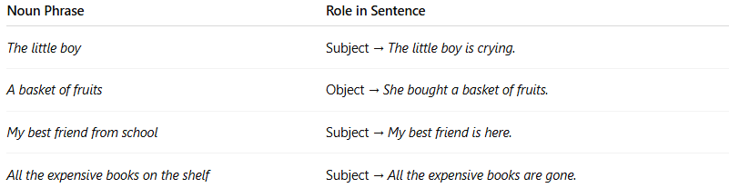
Noun Phrase | Role in Sentence
The little boy | Subject → The little boy is crying.
A basket of fruits | Object → She bought a basket of fruits.
My best friend from school | Subject → My best friend is here.
All the expensive books on the shelf | Subject → All the expensive books are gone.

🔧 Common Noun Phrase Structures:
# Source: Chatgpt (GPT-4-turbo) at [7/28/2025]
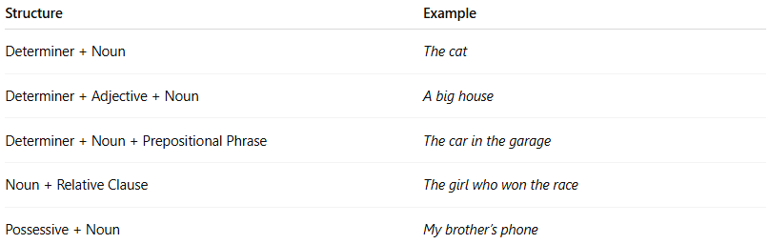
Structure | Example
Determiner + Noun | The cat
Determiner + Adjective + Noun | A big house
Determiner + Noun + Prepositional Phrase | The car in the garage
Noun + Relative Clause | The girl who won the race
Possessive + Noun | My brother’s phone

🧠 Functions of Noun Phrases in Sentences:
# Source: Chatgpt (GPT-4-turbo) at [7/28/2025]
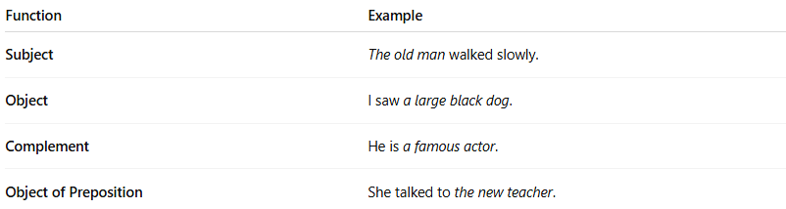
Function | Example
Subject | The old man walked slowly.
Object | I saw a large black dog.
Complement | He is a famous actor.
Object of Preposition | She talked to the new teacher.

📝 Expanded Example:
# Source: Chatgpt (GPT-4-turbo) at [7/28/2025]
Sentence: The tall girl in the red dress smiled.
- Noun Phrase: The tall girl in the red dress
- Head noun: girl
- Pre-modifier: the tall
- Post-modifier: in the red dress

📌 Important Notes:
# Source: Chatgpt (GPT-4-turbo) at [7/28/2025]
- A noun phrase can be as short as one word (e.g., Apples are sweet. → Apples = noun phrase).
- It can also be long and detailed with multiple modifiers.
- Noun phrases often act as the subject or object, but can take other roles too.

🧠 Summary Table:
# Source: Chatgpt (GPT-4-turbo) at [7/28/2025]
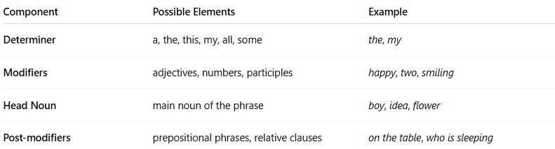
Component | Possible Elements | Example
Determiner | a, the, this, my, all, some | the, my
Modifiers | adjectives, numbers, participles | happy, two, smiling
Head Noun | main noun of the phrase | boy, idea, flower
Post-modifiers | prepositional phrases, relative clauses | on the table, who is sleeping

